Example: Adafruit, BeagleBone and Arduino seem to be the main industrial players

Adruino Uno Example from Amazon (Digi-Key is also an option);

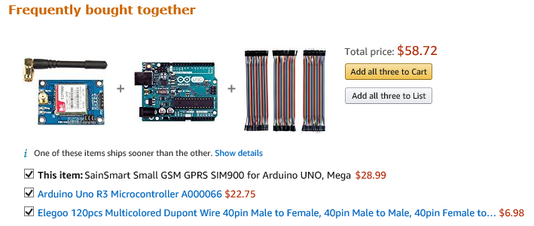

Bread board, power supply, micro-USB and GSM SIM would also be needed.

**First Steps and Suggestions;**

1. System specification and flow-diagram
2. Supplier selection option review, ease of use, costs and performance
3. Software library and development platform(IDE) – Programing language
4. Sensor types and available working slots on controller
5. Mechanical packaging
6. Cloud sharing method (project, program, and data examples)
7. Method(s) to communicate out and present data in real time

file: Board example.docx

Marvin Windows and Doors

Stephen Fisher

9/6/2017